Healthy Food and Your Children

The number of overweight children in Australia has doubled in recent years, with a quarter of children considered overweight or obese. Causes of obesity in children include unhealthy food choices, lack of physical activity and family eating habits. A child’s food habits (good or bad) begin before they start school and children who are taught the “right” way to eat from a young age can avoid many of the health problems associated with being overweight.
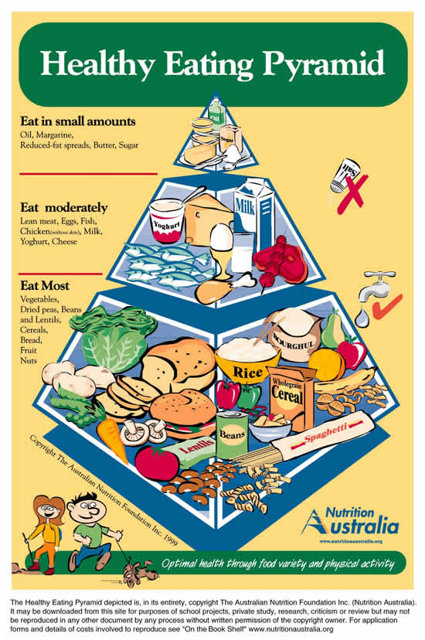
This Healthy Eating Pyramid, published by Nutrition Australia, is a guideline to a balanced diet. The top section (junk food) should be eaten in small amounts, the middle moderately and the bottom section eaten most. On-line calculators can advise the energy and nutrient needs of children (and adults) at different ages. See http://www.eatforhealth.gov.au/eat-health-calculators
Don’t stress if your child does not eat a strictly balanced diet, every child is different. However, if you have real concerns about your child’s eating habits talk to your paediatrician. We are also here to help and can provide information about your child’s eating habits during their time in the service.
Infant’s Diet
For the first months of a baby’s life a baby will get all the nutrients he/she needs from milk (either breast or formula.) Cow’s milk should not be given as the main drink to infants under 12 months (small amounts may be used in the preparation of solid foods). Low-fat and reduced-fat milks are also not recommended. At around age 1 you can begin to wean your child off breast milk or formula. When doing this remember that some children are allergic to cow’s milk.
Solid foods can be introduced at around 6 months of age. First foods introduced should include those which contain iron, including iron fortified cereals, pureed meat and poultry, cooked plain tofu and legumes/beans. Foods can be introduced in any order provided the texture is suitable for the stage of development. Younger infants will need food to be soft so it can be eaten without much chewing. Cow’s milk products including yoghurt, cheese and custard may be given.
Your paediatrician can advise you on exactly how much you should feed your child. There are also resources available online including http://www.eatforhealth.gov.au.

Fussy Eaters
Most children are fussy eaters, and this is totally normal. Below are some strategies for dealing with fussy eaters:
- Children often won’t like a food the first time they try it. Try introducing the food a few more times.
- Only offer a small portion of the food. A bite or two is enough for a new food.
- Don’t bribe a child to eat food they don’t like with the offer of unhealthy food like lollies or junk food.
- Offer your child a choice. If you want him/her to have vegetables or fruit, offer them a choice between fruit/vegetables they like.
- Be a good role model. If your child sees his/her family eating foods they will often want to try them, of accept that those foods are what they are supposed to eat. If possible, try and get your whole family to eat meals together so your child can see what everyone else is eating.
- Make meal times a pleasant experience. Share meal times, turn off the TV and talk to your children.
We hope this has provided some helpful facts about healthy eating for your child. If you have any concerns about your child’s diet and feel that we can help, please feel free to approach us.

Sources
Nutrition Australia. (2009). Nutrition Australia. Retrieved 30 may 2013 from Nutrition Australia: http://www.nutritionaustralia.org/
Better Health Channel Victorian Department of Health Retrieved 30 May 2013
http://www.betterhealth.vic.gov.au/bhcv2/bhcarticles.nsf/pages/Obesity_in_children

